IO1/A3 – National reports

Template for National Report

Poland
MaPa

January 2020

PARTNER LOGO
PARTNER LOGO
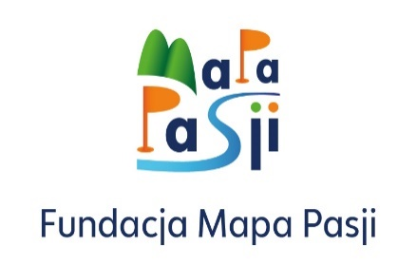

Table of Contents

1. Introduction

  - Objective and scope of the research

Describe briefly the objective of the research (referring to the project) and its scope

Media literacy is the term referring to the acquisition of skills and competences for the use of modern media of all types. MeLi (Media Literacy for parents) project aims to bridge this gap and develop media literacy skills and competences for parents. The project aims at developing a training Programme on media literacy for parents, a web application that will bring media literacy education in their houses and a parents’ guide on media literacy. The training course aims to support the parents’ acquisition with Media in order to enable them to efficiently guide their children when they use the Media.

  - Methodology
Describe briefly the methods used to collect data:
- Desk research: how did you collect data? Which tools did you use to find and select data? When and where did you do the research? What sort of materials / information did you search for?

The desk research was conducted using merely online public sources such as from the Ministry of Education, NGOs, journal articles including postgraduate studies and media articles.

- Questionnaires: when, where and how did you collect answers? What sort of media / channels did you use to promote the survey? How many replies have you collected?
The MeLi questionnaire was uploaded on Google forms translated in Greek language in order to gain online and automatic access on the survey responds and results and to address parents in Cyprus. The research was undertaken from 14th January, 2020 until 14th February, 2020 and 55 responds were totally collected. The survey was sent to parents via emails as well as the questionnaire was provided in the event of the National Educational Fair in Cyprus between 7th to 9th of February, 2020 which Emphasys Centre participated in, and targeted the visitors (parents) who were interested in taking the survey.

- Focus group interview: how did you organize the meeting? How did you choose participants? How many people participate? When was it and how long did it take? What tools / methods did you use during the interview?

The focus group took place at the offices of Emphasys Centre on 13th of February. Five parents participated across parents’ associations of public schools in the meeting and each was asked the following questions:
- Which is the main problem/issue in your opinion that children face when they use Media platforms? Which are the main concerns of the parents? (Digital security, privacy, controlling tools for parents etc.)
- What can the training material and the mobile application to be developed as part of MeLi project should include in order to efficiently respond to the problem?
The above questions were answered by each participant and resulted in the identification of the main concerns/problems parents have in relation to their children’s media exposure. The interviews also included their suggestions in regard to the mobile application and training material development as part of the implementation of MeLi Project.

2. Desk research results

Present the results of the desk research that has been done. Make sure to answer the following questions:
- What is the current policy framework and government’s strategy on media literacy (including -if found - in Digital policy, education policy, youth policy, children policy etc).

The Republic of Cyprus has initiated various measures to promote media literacy in education in the recent years. These measures consist of the introduction of laws and policies as well as take the form of seminars and training programmes addressed to the public. For the purpose of this report, the term of media literacy refers to “the ability to access, understand and critically evaluate the various aspects of media and its content and the ability of expression in different forms of communication, especially through new technologies’’.
The term Media literacy [in greek: Παιδεία για τα Μέσα] first appeared in legal documents in December 2010 upon the transposition of the AVMS Directive into the laws governing commercial and public broadcasters in Cyprus. The Cyprus Radio Television authority (CRTA) has been harmonized with the European Law 2007/65/EC which states that the term of media literacy shall integrate in the Radio and Television Stations Law 7 (I) of 1998. CRTA has developed a Special Committee encompassed by experts in order to plan actions for the promotion of Media literacy. The Committee has initiated measures related to the organization of seminars which promote media literacy skills as well as meetings with public and cooperates with the Ministry of Education and Culture (MoEC). The main objective of the media literacy initiative by CRTA is to equip individuals with critical thinking skills and the ability to evaluate the messages and images they daily expose to on Media. It is noted that CRTA is an independent regulatory body in the sphere of broadcasting and is responsible for the effective regulation and constructive control of private and partially broadcasting in Cyprus. Activities undertaken by CRTA related to media education for children refer to the development of an information campaign through the production of short advertisement films intended to be broadcast in order to raise awareness, inform the public and influence children to evaluate media content. Additionally, media literacy workshops were organized and were applicable to children across all educational levels. These workshops aimed at promoting conscious consumer behavior, raise democratic values and support children’s’ critical thinking when reading media content.
The Ministry of Education and Culture (MoEC) has initiated practices in the recent years related to the promotion of media literacy in schools. The first attempt was made in 2012 in the context of creating a ‘humanitarian and democratic school’. This initiative focused on developing attitudes and behaviors which characterize a democratic citizen. Toward this end, media literacy education was taught in schools and aimed at identifying and evaluating the messages children receive on Media as well as aimed to teach them the ways to express themselves through media platforms. Importantly, critical literacy is embedded in Cyprus Educational context. Specifically, critical literacy in Cyprus education system refers to the development of skills which overcome the challenges faced in the 21st century such as competences in research, comparison and evaluation of meanings. The subject of critical literacy is embedded in the modern Greek course in Cyprus public schools. The pedagogy encompasses of critical literacy method which that implies that texts are read as acts interconnected with sociocultural phenomena. The specific pedagogy emphasizes the evaluation of texts through reading and writing and is strongly connected with the development of critical thinking skills.
Nevertheless, media literacy initiatives are very limited in education and actions related to the promotion of media literacy to students are emerged mostly as informative seminars. Efforts by teachers are made to include media literacy in their lessons as part of the modern Greek course as previously mentioned. Such an example is the production process and role of advertising, the utility and influence of advertisements in individuals’ lives. During this lesson, officers of the Radio Television Authority are often invited by teachers to talk to students about issues of radio and television broadcasting. As a result, media education is currently not formally included in the national curricula of primary and secondary education in Cyprus and it is better described by individual initiatives taken by teachers in public and private schools on a voluntary basis or as extra-curricular activities.
Further so, the Pedagogical Institute - which is the government institution responsible for informing educational policy and advising MoEC on issues regarding the constant development of teachers- plans to create a website on which teachers can describe all the actions made for promoting media literacy to children in education. Through collaboration with universities and research centers, the Institute has played an influential and positive role in supporting and implementing research and initiatives emphasizing learning innovations as well as training and further development of teaching staff. The lack of a detailed and common policy framework forced competent bodies to seek remedies so that media education is offered to some extent by the Institute. A variety of activities are undertaken within the public educational system to provide training to teachers and specialised education to students in regards to media literacy. Computer literacy and Internet safety have been two privileged training targets, with the former being a course in the national curriculum. The Institute also manages to undertake other media education activities within the framework of European projects.
Media education in Cyprus has primarily been focusing on children and young adults within the context of integrating media and information technologies into teaching, learning and creative expression. Nevertheless, specific and detailed educational programs and policy agendas are absent. Importantly, Cyprus is classified as a country of higher levels of internet use and personal/mobile internet access, which that has posted new challenges for internet safety initiatives. However, a research by the EU Kids Online project found that children in Cyprus rank low on critical literacy and safety skills regarding changing filter preferences, comparing websites to decide if the content is true, blocking unwanted adverts or junk mail/spam and finding information on how to use the internet safely. The public also has had access since 2007 to an awareness centre with a hotline which is a Helpline and organises public events promoting internet safety.
Due to the lack of a clear media education policy and detailed and concise implementation strategies, schools and civil organizations or through collaboration between these actors with governmental support, media education training programs do not respond directly to any formal accountability. Combined with the absence of a commonly agreed framework on media literacy and media education, a consistent evaluation system, formal or informal and designated regulatory authorities to reinforce mechanisms are yet not existed in the policy framework.

- Who (both people and institutions) deals with “media literacy” in your country: we need a list of stakeholders with information, what they do, what they offer to different target groups (do they have a special offer for parents?); the following table will be useful:

Name of an expert / institution dealing with media literacy | Contact data (a website address / contact person) | Offer (what can they deliver – trainings? Articles? Applications? Etc.) What is their speciality? Which methods do they use? | Target group(s) – to whom do they address? | Other comments / additional information (for example: innovations? Impact? Transferability?
University of Cyprus Radio Station | Website: https://ucy.ac.cy/ucyvoice/en/  Contact Person: Stella Stylianou  E-mail: ucyvoice@ucy.ac.cy | Training programme titled ‘Media Literacy’ which includes seminars and workshops by academics and media professionals that aim to inform students on issues of journalism ethics, human rights, cultural creation and other. Seminars and workshops are also offered to improve radio production, journalistic writing, radio speech, orthophony and speech therapy skills. | Adult students
Cyprus Literacy Promotion Organisation | Website: https://grammatismos.wordpress.com/about/  Contact Person: Zacharoula Mala  Email address: grammatismoscyprus@gmail.com | The NGO and organises events which aim to inform citizens on issues related to literacy practices and the promotion of challenges awarness. The NGO cooperates with public bodies to promote literacy skills to all actors within the public. Also, it develops campaigns such as ‘Fairytales of Goodnights’ which provides the opportunity to parents to promote literacy skills to their children. | Children and Parents
Cyprus Pedagogical Institute, Ministry of Education, Culture | Website: http://www.pi.ac.cy/  Contact person: Spyros Sofokleous  E-mail address: info@cyearn.pi.ac.cy  literacy_cyprus@cyearn.pi.ac.cy | The Institute in cooperation with public bodies such as the University of Cyprus, Ministry of Education etc. offers seminars out of charge that are addressed to the public and are related to media literacy and school education. It emphasises school literacy for children in primary and secondary education aiming at developing literacy and critical thinking skills. The Institute also offers seminars and trainings targeted to parents aiming at identifying the needs of each school and supports children’s learning developmentThe Institute offers compulsory courses to teachers to ensure educational progress. | Educators,  Students of undegraduate, postgraduate and Phd studies, academicians, researchers, parents, NGOs | The Cyprus Pedagogical Institute is the main public body aiming at ensuring teachers of all levels to keep up with current trends in education as well as it informs the education policy of the state through educational research and evaluation reports.

- “Media literacy” in my country – an overall view and conclusions from the desk research Please, be analytical! Compare the existing offers and choose the most interesting ones. Is there any offer in media literacy for parents?

The following table shows some of the good practices on media literacy in Cyprus:

 | Good practice Title | Responsible Organizations | Target Group | Description
1 | Congress- ‘Literacy and Contemporary Society: Spaces, Discourses, Practices’ (2017) | - Ministry of Education and Culture  - Cyprus Pedagogical Institute  - Cyprus Literacy Promotion Organisation  - Cyprus Association of Librarians Information Scientists (CALIS)  - Youth Board of Cyprus | - Public Bodies and Government Office  - NGOs  - Schools  - Public | The event aimed at planning and presenting the social practices in regards to promoting literacy in education in Cyprus. The symposium communicated the needs and actions that need to be taken in order to ensure the efficiency of the activities the participating organisations need to undertake in relation to advancing literacy skills to the public.
2 | Education Programme- ‘Beauty Standards on Media and their critical evaluation’ (2017) | - Mrs. Kallitsi  (University of Cyprus)  - 3 Public Schools in Cyprus | - Pupils aged 9 to 11 years | A study was conducted to investigate how pupils critically evaluate beauty standards online, advertising campaigns, online articles and content development. The study took place during the classroom in three primary schools in Cyprus. Pupils worked in teams and independently, were provided educational information and produced their own assessment on their perceptions on media content.
3 | Communication and Education in 2016- Workshop | - Independent Teacher and Kindergarten Movement (A.KIDA) | - Teachers  - Educators  - Parents | The workshop aimed at identifying the ways media literacy can be included in education and in the national curriculum. Teachers have expressed a great interest in developing their skills in order to properly train pupils on media literacy.
4 | Media Literacy Workshop- 2019 | - Cyprus Pedagogical Institute | - Teachers  - Students across primary and secondary education | The workshop aimed at raising awareness to students and teachers about media literacy, promoted the creative use of Media in educational processes and influenced the participants to deepen their role on Media in order to critically evaluate media content and not only be observes/ consumers of its content.

3. Questionnaires’ results

Present the results of the questionnaires – how many people replied? Each question from the questionnaire should be presented with a simple graphic / table and a short comment about the result.

As part of the implementation of MeLi project, a survey was conducted to investigate and assess parents’ needs in respect to addressing Media Literacy skills’ development to their children. Emphasys Centre undertook a survey for parents in Cyprus using an online questionnaire in Greek language via Google Forms. Total responds account to 55 participants in which 34 responses were answered by women and 21 by men.

The following charts show the demographic characteristics of the responders:

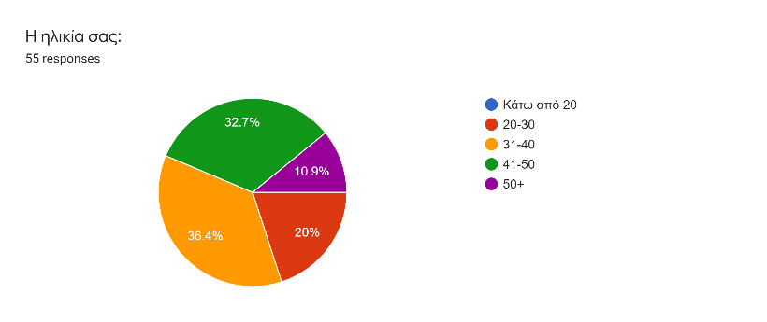
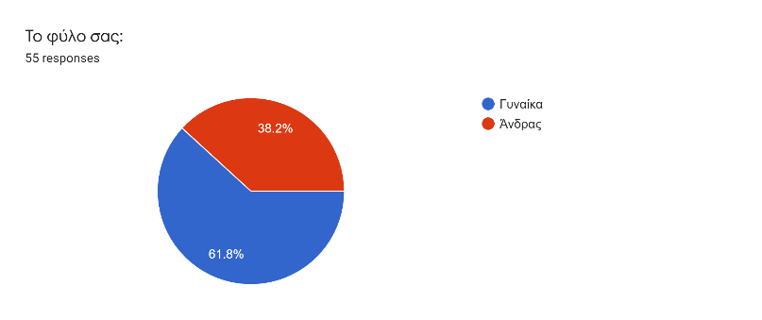
Chart I: Sex of participants Chart II: Age of participants

As the above charts show, 60% of responders i.e. 34 participants i.e.31.8% were female and 38.2% were male i.e. 21. Most of the participants who took the survey were between 31 and 50 years old. Specifically, 18 people were between 41 and 50 years old, 20 of the responders were between 31 and 40, 11 were between 20 and 30 years old and 6 of the responders were above 50. The survey is divided into two parts: (1) Demographic information and (2) Education in Media Literacy.

(1) Demographic Information

Figure I: Age of participants’ children
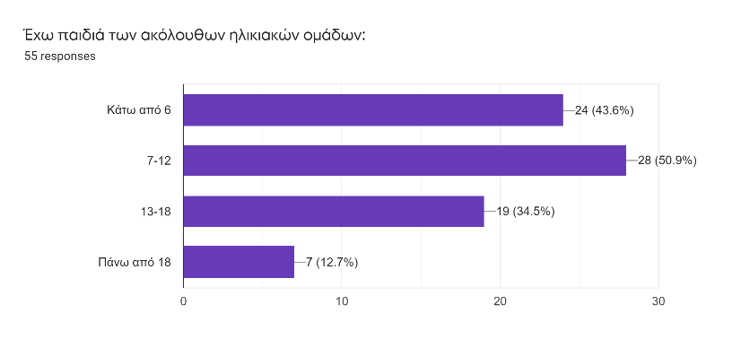

Figure I demonstrates the age of the children of the responders. Most of the parents who participated in the survey have children between 0 and 12 years old.

Chart III: Place of living
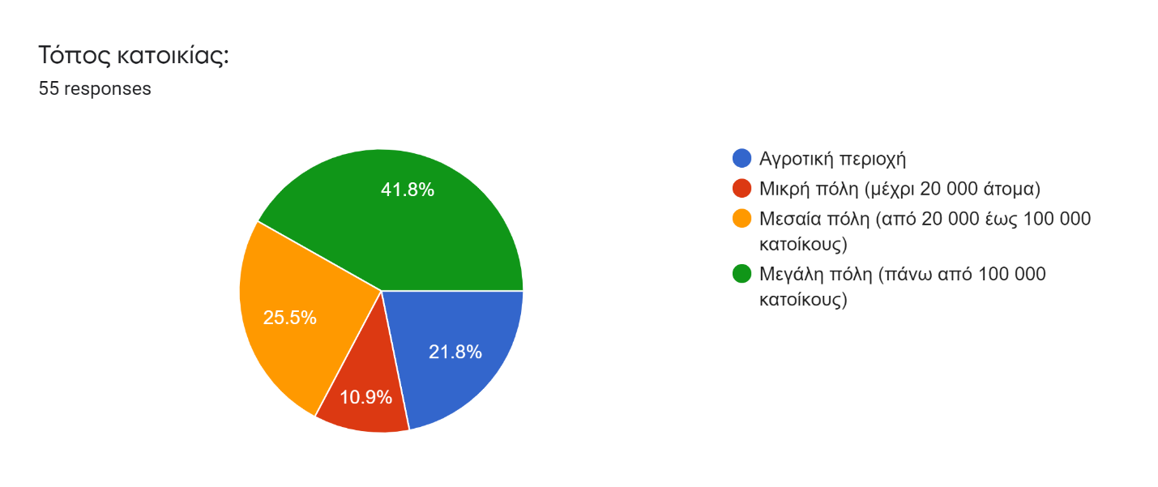
41.8% of the participants of the survey live in a big city while 25.5% in a city less than 100.000 inhabitants. 10.9% of the responders live in a small city and 21.8% in rural areas in Cyprus.

Chart IV: Academic level of participants:
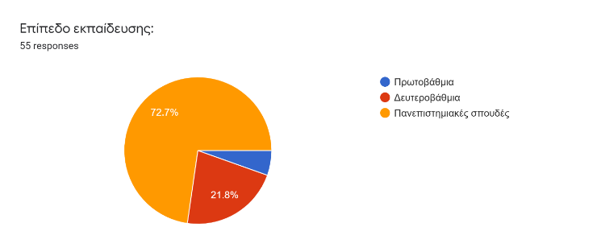
Chart IV shows that most of the responders -specifically 72.7%- have completed university studies. 3 of the responders have completed primary education and 21.8% are graduates of secondary education.

Chart V: Media Literacy Knowledge
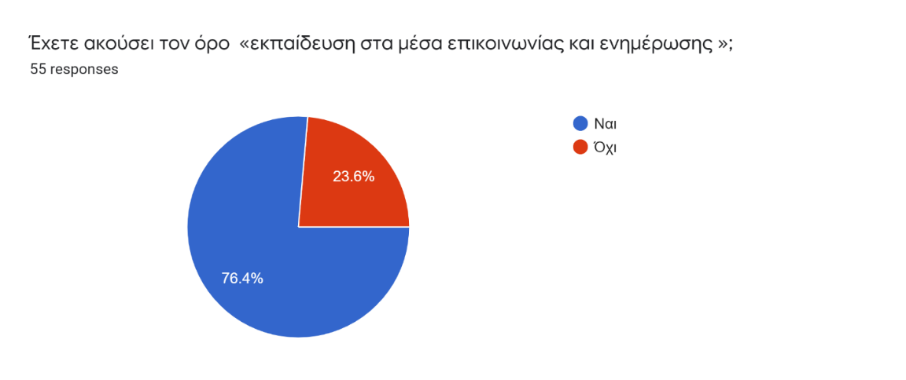

The chart reflects parents’ acquisition with the term of Media Literacy. The responders who have heard the term of Media Literacy reached 76.4% i.e. 42 of the participants. Notably, most of the responders’ age who have previously heard the term are between 31 and 40 years old whereas, none of the responders aged 50 and above has ever heard the term.

2. Education level in Media Literacy

Figure II: Level of education of participants in Media Literacy

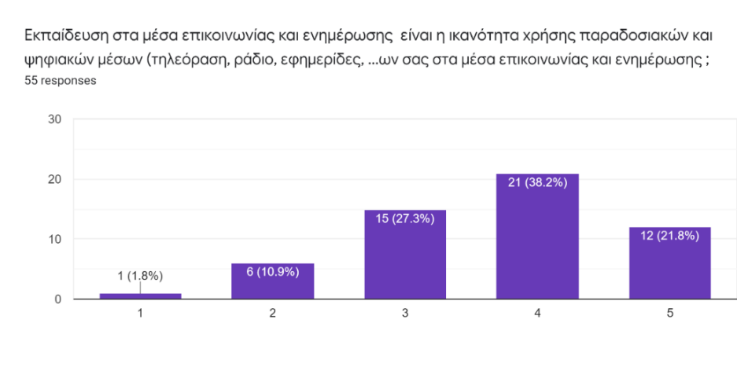

The figure above illustrates the level of education of the participants in Media Literacy. Most of the responders assessed their ability level 4 out of 5 in using traditional and digital media. 1 participant assessed himself as low as 1 out of 5 and 6 assessed themselves 2 out of 5 who are aged 41 to 50. Importantly noted, most of the participants who evaluated their level of ability in using Digital and Traditional Media high i.e. between 3 and 5 are aged 20 to 40 years old.

Figure III: Media channels/platforms participants use
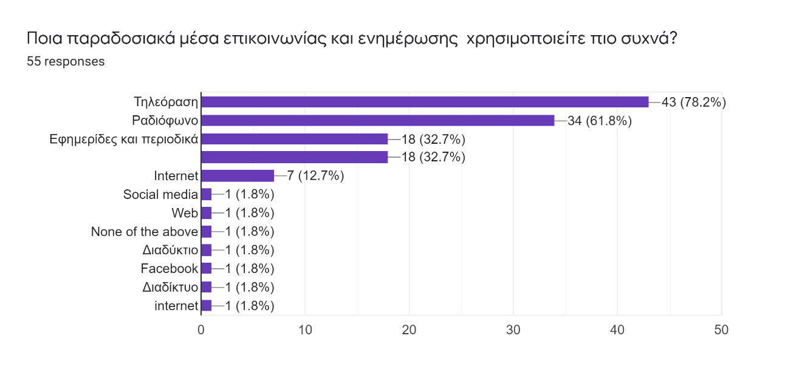
Figure III reflects the media platforms that the responders use daily. 31 of the participants responded that they use online platforms (Internet, Web, Social Media, Facebook) while 78.2% of the participants use television, 61.8% use radio and 32.7% use newspapers/ magazines.

Figure IV: Sources participants use to gain knoweldge on digital media

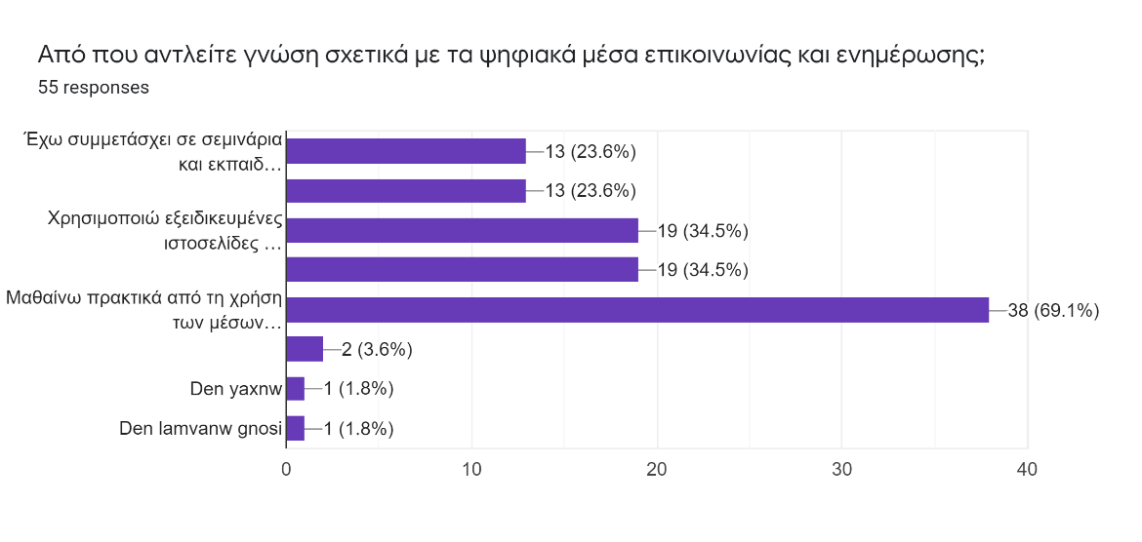

Figure IV shows the sources parents use to receive knowledge on digital media. Most of the participants i.e. 69.1% have responded that they use digital platforms to learn about digital media issues. 34.5% use specialised websites and 23.6% have acquired knowledge through their attendance on training seminars.

Figure V: Digital channels parents use

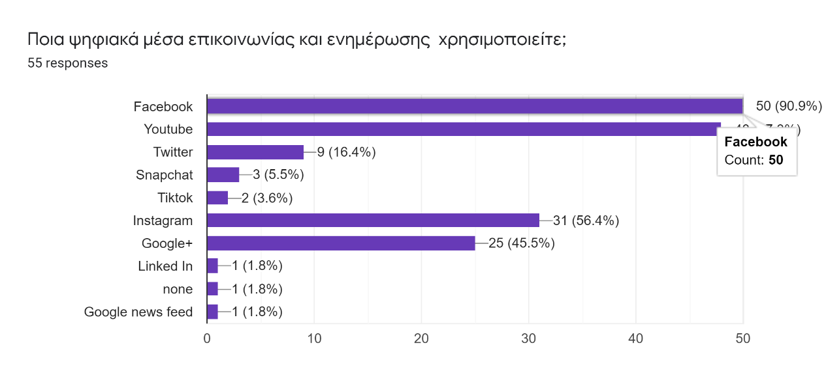
As showed in Figure V, most of the parents in Cyprus use Facebook and YouTube channels. 56.4% of the responders use Instagram and 45.5% have a Google+ account. Linked in and google news feed are not much used whereas only 2 out of 55 responders use TikTok and 3 people use Snapchat.

Figure VI: Reason parents use digital or other media
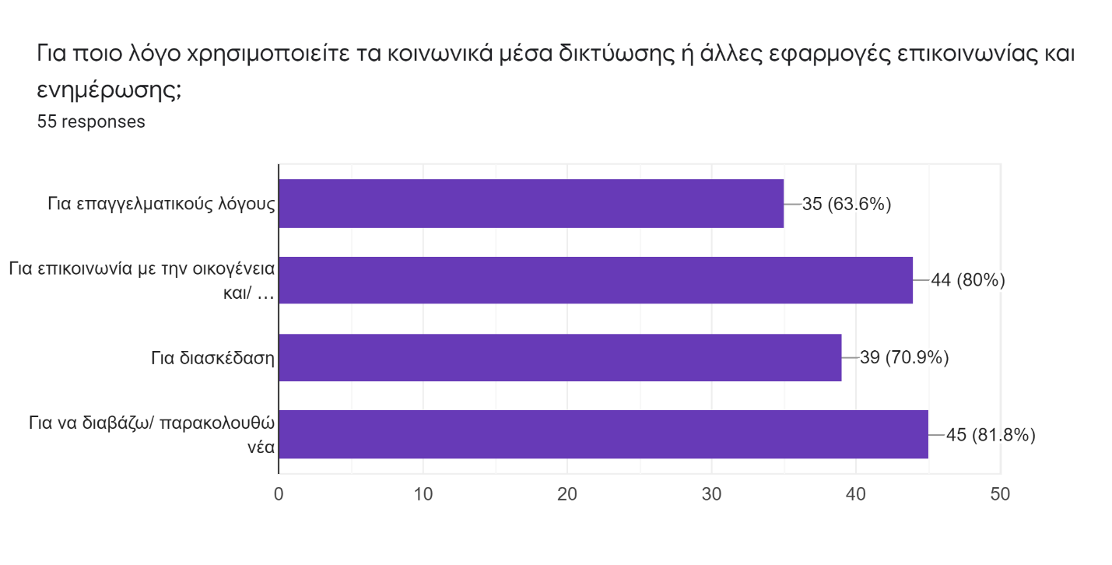

Figure VI displays the reasons parents in Cyprus use online and traditional media. 81.8% of the parents in Cyprus responded that they use digital Media in order to read the news while 80% of the responders claimed that they use digital media to communicate with family and friends. 70.9% use Media channels for entertainment reasons and 63.6% for professional purposes.

Chart VI: Parents’ awareness on their children’s use of Media
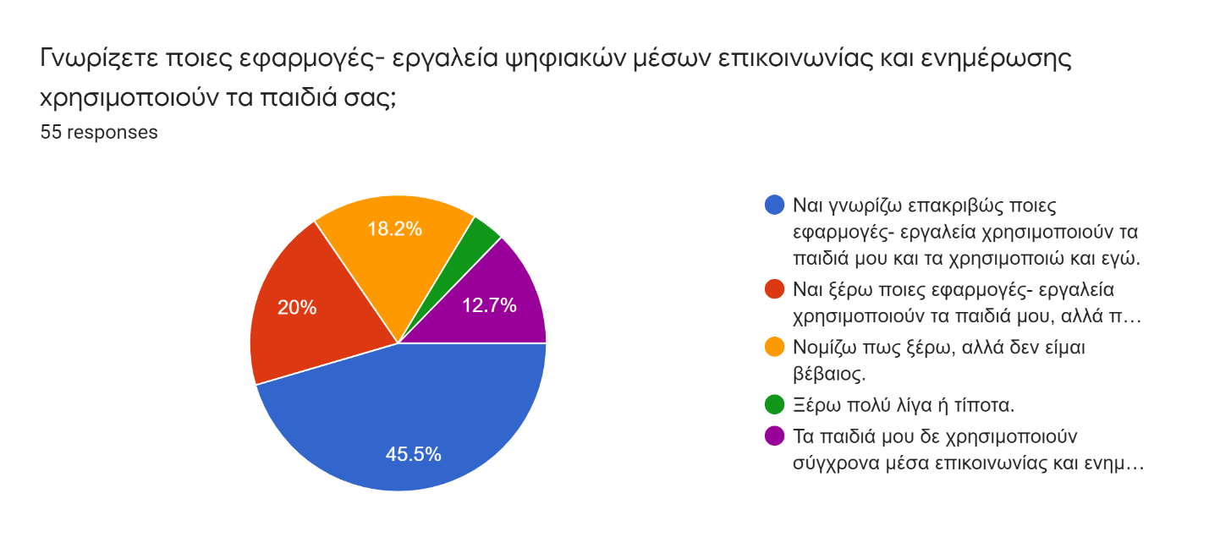

The above chart reflects the level of awareness of parents in respect to the tools-applications their children use. 45.5% of the parents responded that they are aware of the tools used by their children and they use them as well. 20% of the responders noted that they are aware but they don’t use the same tools or applications as their children. 12.7% noted that their children do not use digital media while 18.2% responded that ‘they think they know what their children use but they are not sure’. Importantly noted, parents who have children between 13-18 years old and above have mostly responded that are somewhat aware of their children involvement on digital media and parents who have children aged 7-12 and under 6 stated that they are aware of what applications and tools are used by their children.

Chart VII: Parents perception on their children involvement on social media
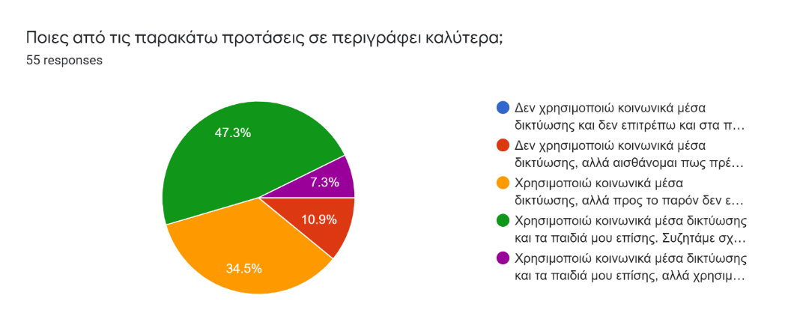

The chart above shows the perceptions of parents in Cyprus in regards to their children involvement on social media. 47.3% of the survey participants responded that they communicate with their children about social media and think that are aware of how they use social media but they need to learn more. 10.9% responded that they do not use social media but their children do and feel that they need to learn more in order to protect their children when they use them. Additionally, 7.3% of the parents claimed that they use different platforms than their children and need to learn more about the new trends on social media.

Chart VIII: Parents’ interest on attending the MeLi course related to Media Literacy

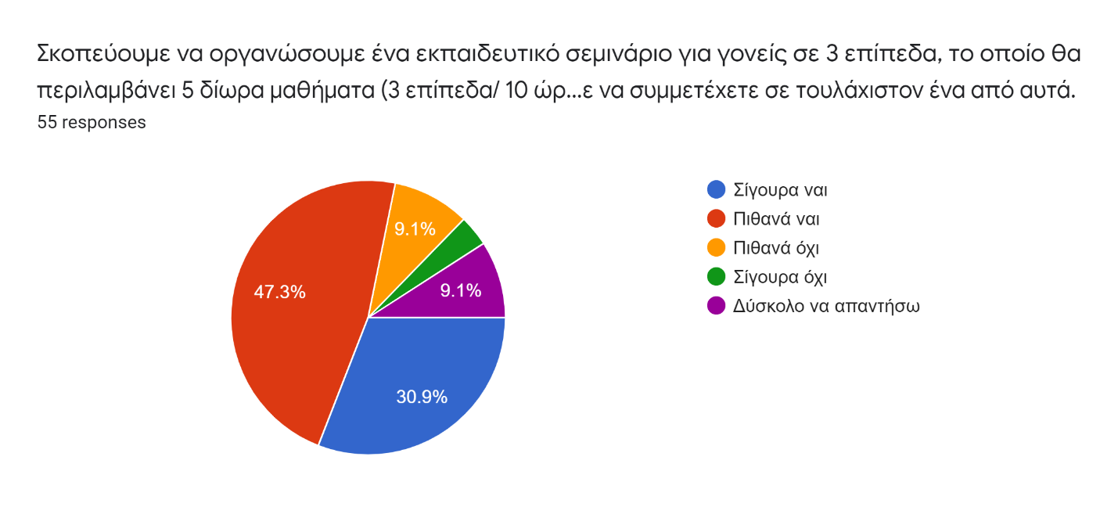

In the chart above, 47.3% participants of the survey responded that most probably they will be interested in attending a training seminar related to media literacy. 30.9% stated that they will surely be interested in attending the course. Also, 9.1% said that they are not sure as well as 9.1% said that they will probably not be interested in. 2 out 55 participants responded that they are definitely not interested in attending the course.

Figure VII: Parents’ perception on the topics to be included in the training course
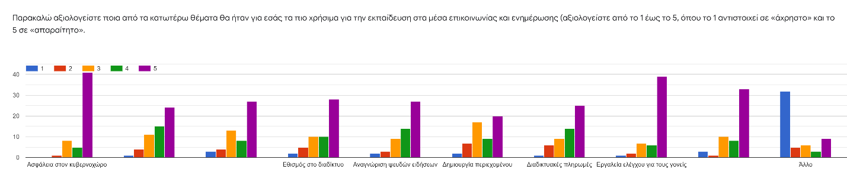
As figure VII shows, parents assess that controlling tools for parents and cyber security are the most important issues to be taken in mind when designing the training course. Privacy and digital footprints, useful family advices, fake news recognition and internet addiction are also to bear in mind. At a lower scale, parents assessed that online payments and netiquette are important issues to be included in the training course to be developed. 15 of the responders who have stated ‘other’ issues included ‘shopping advice, practical exercises and ways to communicate with children without scary them away’.

Figure VIII: Parents’ opinion on the training methods to be used

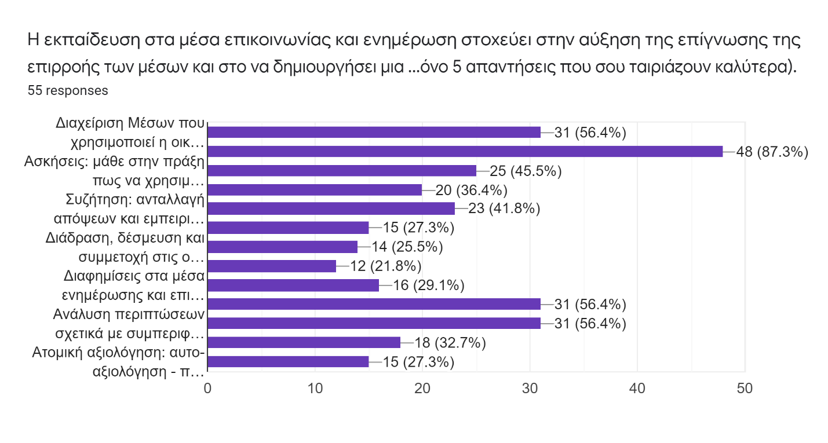
Figure VIII shows the training methods that parents find more interesting to be used as part of the training course to be developed. 48 out of 55 parents i.e. 87.3% showed a great interest in cyber security issues. 45.5% expressed their interest in undertaking exercises related to how they should use the media platforms their children use. 36.4% of the responders showed an interest in social networking while an interest in discussion matters to reflect experiences and opinions among the parents’ accounts to 41.8% of the participants’ responses. 56.4% of the parents expressed interest in the topic of case analysis concerning protection of privacy, family media management as well as exercises concerning online behaviour. 27.3% of the responders were interested in the issue of role models and stereotyped generated on digital media, 25.5% suggested that discussions with other parents on children’s involvement on digital media will be helpful and 29.1% to learn more about the role of advertisements. Lastly, 27.3% of parents expressed an interest in self-assessment as well as 32.7% responded that a case analysis on evaluating fake news will be important to be included in the training course.

Chart IX: Interest in the practical application of the training course
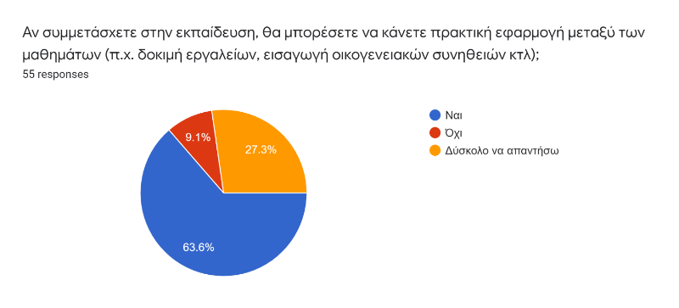

63.6% of the parents participated in the survey of MeLi Project responded that activities related to the training course to be provided to them will be incorporated during attendance of the training. 27.3% said that ‘it is difficult to answer the question’ and 9.1% were negative.

Chart X: Parents’ interest in attending the training course
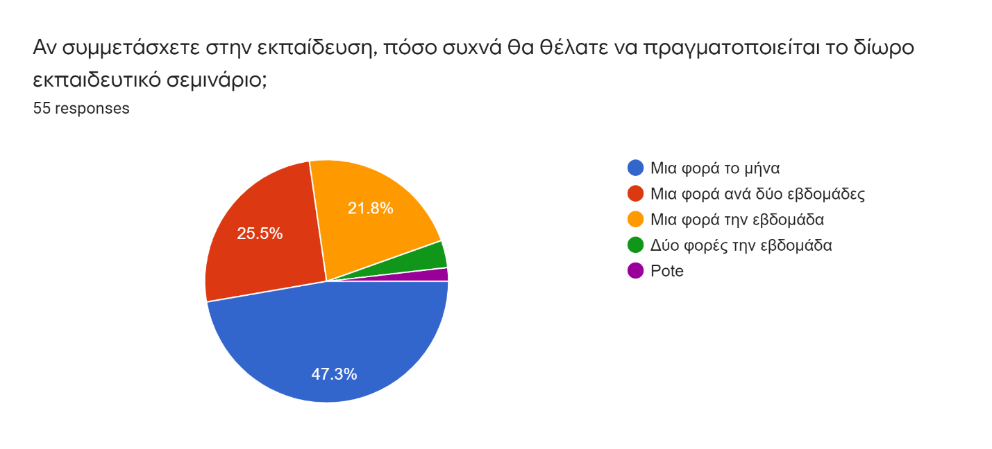

The chart above explains parents’ interest in attending the training course to be developed. Most of the parents said that they will be interested in attending the course once a month whereas, 25.5% responded that they could attend the course one in a two weeks’ time. 21.8% said that they can attend the course once a week while 3.6% i.e. 2 out 55 participants answered 2 times a week. 1 of the responders noted that he would ‘never’ attend the course.

Chart XI: Parents’ interest in the development of a web platform related to media literacy skills development
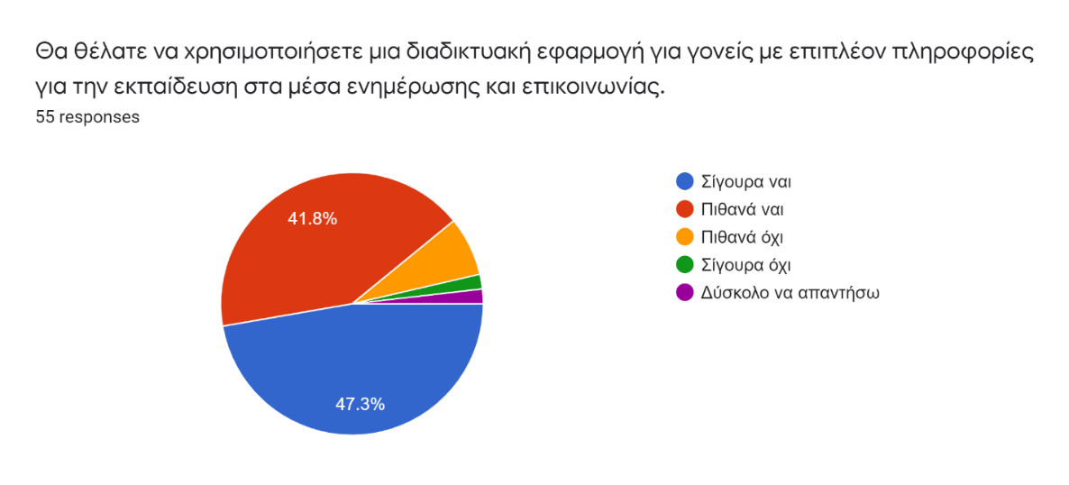
Chart XI shows parents’ opinion on the development of a web platform which will be educating them in Media Literacy. Most of the parents answered that they will be interested in it. Specifically, 47.3% noted ‘Yes, surely’ and 41.8% responded ‘Yes, probably’. 7.3% of the responders stated that they are probably not interested in using the platform and 1 participant stated that he/she is surely not interested in it.

A short paragraph resuming the main conclusions should be added at the end of this chapter:
- What are the main characteristics of the responding people?
- What are their main needs / expectations / interests?
- How many people showed their interest to the project (i.e. gave one’s e-mail address)?

- Overall, most of the participants who took the survey are parents between 31 and 50 years old and live in urban areas and have completed higher education. Most of their children are under 6 to 18 years old. Importantly, most of the parents who participated in the survey recognise the term of Media Literacy and assess their level of ability as high in using traditional and digital media. Most parents in Cyprus use Television, radio, Social Media, internet, newspapers and magazines. Social media such as Facebook, YouTube and Instagram are among the platforms mostly used among the parents. Among the reasons most of the parents who participated in the survey use social media are because of communication with friends and family and for reading the news. Parents get informed about digital media through online means or through friends and family members as well as through specialised websites.
- Parents seem mostly to be aware of the Media tools and applications that their children use and show a great interest in keeping up with current trends. Most of the parents who have children aged between 0 and 12 do not allow their children to use social media. The main concerns of the parents in regards to their children’s involvement on media are found to be cyber security and the need to develop control tools for parents and family media management. Furthermore, parents in Cyprus would like to learn more about cyber security, protection of their children online through exercises, case analysis in respect to the behaviour online, management of digital tools the family uses as well as show an interest in discussing and communicating opinions and experiences with other parents in relation to their children’s media exposure and involvement.
- Most of the participants expressed a great interest in attending an educational course in Media literacy for parents and noted that they mostly would be able to attend it once a month. Also, parents showed an interest in using a web application designed for developing media literacy skills. Overall, 25 out of 55 participants provided their email address in order to keep up with MeLi Project development and attend the training course.

4. Focus group interview

Briefly present the interviewees, their backgrounds, experiences and expertise

 | Name | Profession | Organization | Information (No of children, Age)
1 | Pantelis Thrasyvoulou | Army | Parents association of Lyceum of Ap. Varnava | 2 Children, 16 and 24 years old
2 | Maria Misou | Housewife | Parents Association of Primary School Agios Dimitrios Xylophagou, Larnaca | 1 child, 9 years old
3 | Eleni Ttofa | Director of Kindergarten | Director of public kindergarten | 2 children, 9 and 12 years old
4 | Elena Theodosidaou | Educator | Member of the Parents’ Association of Macedonitissa A’ Primary School | 2 children, 12 and 22 years old
5 | Persa Polyviou | Journalist | Vice president of the Parents’ Association of Egkomi B’ Primary School | 2 children 5 and 11 years old

Describe the collected results, in particular,
- Describe the main issues that you wanted to clarify / understand / deepen during the interview (taking into account the results of the questionnaires)
- Describe the main conclusions from the discussion

The following table might be useful:

Issue / Problem | Answer / conclusion
- Online safety for their children  - Social media posting | - Proper methods to educate children when they use social media  - Controlling tools for parents
- Screen addiction,  - Behavior change,  - Social isolation,  - Media forces bad role models on children | - Controlling tools for parents (time restriction and content)  - Anything else that can help me to understand whether his behavior can be affected by social media and ways to help/support him become social  - Suggestion: Acquire knowledge on e.g. robotics so I teach my kids how we can use technology in a fancy and productive way
- Screen addiction  - Cyber security  - Applications used that we are not aware | - Controlling tools for parents  - Communication methods to attract children’s discussion in the right ways to use social media
- Privacy, exposure of personal data without realizing it.  - Change of behavior in an on and off line communication  - Addiction of use of social media  - Usually parents worry about the safety of the children when they use social media, their exposure to the rest of the users and their healthy behavior towards the use of social media. Apart from that, as usually the behavior of young people changes on-line this affects their F2F communication. As a result, young people become isolated and depressed. This is a real danger for their well-being. | - Tips on how parents can deal with these issues.  - List of resources, videos, tools etc. which parents can use to be informed about the dangers and how to prevent them.
- Although my children are young, at the age of 10 my daughter has started using Tik-Tok and Viber. Initially, I thought it was quite cool and interesting to see her communicating with her friends. However, as the time was passing by, I realized the dangers that were entailed in this type of communication.  - One of the main issues, was the use of language GREEKLISH, the way of expressing their emotions as no one could see them and the acceptance or approval of something they uploaded on Tik-Tok by others.  - Number of LIKES was a big issue. | - Motivational videos showing positive and negative use of social media will help children to understand issues.  - An A to Z Guide into the use of social media, terminology or glossary might also be useful.

3. Conclusions and recommendations
Comment the collected results and provide recommendations at national level, especially present your reflections and suggestions concerning the training programme.
The national report for Cyprus studied the integration of Media literacy in national policies and strategies as well as offered an analysis on the bodies responsible for educating the public such as educators and parents, about Media Literacy. For the purpose of evaluating the current scene in relation to the needs of parents and the issues to be taken in mind when designing the training course, the national report includes a survey targeted to parents as well as a Focus Group interview which targeted parents involved in parents’ boards and associations.
The national report for Cyprus studied the integration of Media literacy in national policies and strategies as well as offered an analysis on the bodies and organisations responsible for educating the public about Media Literacy. The report evaluates the current scene of the needs of parents and issues to be taken in mind when designing the training course. It includes a survey targeted to parents as well as a Focus Group interview which targeted parents involved in parents’ boards and associations.
Notably, Cyprus has initiated a number of measures to promote media literacy in the last years. These measures consist of the introduction of laws and policies as well as take the form of seminars and training programmes addressed to the public. The first step to integrate Media Literacy in the law was the introduction of the European Law 2007/65/EC. That implied that the Cyprus Radio Television authority which is the responsible body for the effective regulation and constructive control of private and partially broadcasting in Cyprus has included the term of media literacy in the Radio and Television Stations Law 7 (I) of 1998. Moreover, the Ministry of Education and Culture has since initiated practices related to the promotion of media literacy in schools. The courses take the form of informal teaching and take place as part of the modern Greek course. These courses aim to identify and evaluate the messages children receive on Media as well as to teach them the ways to express themselves through media platforms. The pedagogy used for critical literacy in school education in Cyprus has played a vital role in the educational context in terms of developing critical thinking and research skills for the students. Media education furthermore in Cyprus has primarily been focusing on children and young adults within the context of integrating media and information technologies into teaching, learning and creative expression.
Moreover, the Cyprus Pedagogical Institute which runs under the auspices of Ministry of Education and Culture, has played an influential and positive role in supporting and implementing research and initiatives emphasizing learning innovations as well as training and further development of teaching staff. Through strong cooperation with schools and public bodies, the Institute offers a variety of activities within the public educational system to provide training to teachers and specialised education to students.
Overall in Cyprus, some of the organisastions responsible for promoting Media Literacy are the Cyprus Pedagogical Institute, Cyprus Literacy Promotion Organisation, University of Cyprus Radio Station and Cyprus Radio Television Authority. Nevertheless, specific and detailed educational programs and policy agendas are absent. Due to the lack of a clear media education policy and detailed and concise implementation strategies, schools and civil organizations or through collaboration between these actors with governmental support, media education training programs do not respond directly to any formal accountability. Also, no specific strategies or policies refer to parents acquisition with media literacy.
The survey concluded that developing a training programme which will support parents’ acquisition with Media Literacy in order to guide their children’s enagement in Media is a prequisite. The lack of a policy framework and strategy which supports parents’ needs toward this end, is believed to play a key role for the development of a specialised training course on Media literacy for parents. Through the survey, parents expressed their concerns in terms of their children’s involvement on digital media. Cyber security, family media management, controlling tools for parents and the need to keeping up with media trends are some of the issues parents find extremely important to be included in the training programme. The focus group moreover illustrated that behaviour change, social isolation, screen addiction and lack of critical thinking of children when they use social media such as through posting and exposure are key concerns of parents. Participating members in the focus group suggested that the main solutions to overcome the challenges faced by children on digital media are the introduction of controlling tools for parents and the creation of Media literacy glossary to effectively guide children on how to engange in media platforms and on the web.
As a result, it is suggested that Media Education should be integrated in the Cyprus national curriculum as an obligatory course for all students as no formal training currently runs. Also, a stronger cooperation between schools and parents to identify needs of the children is important element for educating children on Media Literacy. As suggested in the survey, cyber security, family management and parents’ acquisition with social media trends are among the topics parents wish to learn more about. Moreover, a glossary of Media Literacy for Parents offering a guidance to parents for the effective learning methods to be used to their children is also believed to be important for the development of a successful training course. The platofrm moreover is suggested to include a communication tool where parents will have the opportunity to discuss issues relevant to their children’s involvement on Media as well as develop exercises to support the way they shall guide their children when they engage on online media.

Attachments:
Please, attach the full Excel sheet with the data collected through the questionnaire (raw data exported from the Google form that you used)

CRTA (2017) ‘Κείμενο Εργασίας- Παιδίεα για τα Μέσα’ . Available at: http://www.crta.org.cy/images/users/1/Media%20Literacy-white%20paper%204.1.17.pdf
University of Nicosia (2014) ‘Media and Information Literacy Policies in Cyprus’. Available at: http://ppemi.ens-cachan.fr/data/media/colloque140528/rapports/CYPRUS_2014.pdf
CRTA (2014) ‘Media Literacy’. Available at: http://www.crta.org.cy/images/users/1/MEDIA%20LITERACY-introduction.pdf
Departnment of Communication Sciences, University of Zagreb (2014) ‘Media Education for Children in Cyprus: An empirical Case- Study’.
Sigmalive (2012) ‘Εκπαίδευση στα σχολεία για τα μέσα μαζικής επικοινωνίας’. Available at: https://www.sigmalive.com/news/local/8380/ekpaidefsi-sta-sxoleia-gia-ta-mesa-mazikis-epikoinonias
MoEC (2018) ‘Γραμματισμός: «κριτικός (δεν) είναι και (δε) φένεται» Ενδείξεις από ανταστοχαστικές συχητήσεις με εκπαιδευτικούς της Δημοτικής Εκπαίδευσης’. Available at: http://archeia.moec.gov.cy/sd/288/mavri_dimosiefsipek.pdf
MoEC (2020) ‘Το Παιδαγωγικό Ινστιτούτο Κύπρου - Γενικές Πληροφορίες’ Available at: http://www.pi.ac.cy/pi/index.php?option=com_content&view=article&id=329&Itemid=158&lang=en
UCY (2020) ‘Media Literacy’. Available at: https://ucy.ac.cy/ucyvoice/en/media-literacy
Pancyprian Organisation Promotiong of Literacy (2017) ‘Πρόγραμμα στηρίζω τις βιβλιοθήκες’. Available at: https://grammatismos.wordpress.com/events/%cf%80%cf%81%ce%bf%ce%b3%cf%81%ce%b1%ce%bc%ce%bc%ce%b1-%cf%83%cf%84%ce%b7%cf%81%ce%b9%ce%b6%cf%89-%cf%84%ce%b9%cf%83-%ce%b2%ce%b9%ce%b2%ce%bb%ce%b9%ce%bf%ce%b8%ce%b7%ce%ba%ce%b5%cf%83/
Cyprus Pedagogical Institute (207) ‘2^{ο} Διεθνές Συνέδριο: Γραμματισμός και Σύγχρονη Κοινωνία: Χώροι, Λόγοι, Πρακτικές΄. Available at: http://www.pi.ac.cy/pi/files/epimorfosi/synedria/literacy/2017/2nd_Lit_Con_Proceedings.pdf
University of Cyprus (2017) ‘Κριτικός Γραμματισμός στα ΜΜΕ: Μια πρακτική εφαρμογή εκπαιδευτικής παρέμβασης σχετικά με τα πρότυπα ομορφιάς στα ΜΜΕ’. Available at: http://www.pi.ac.cy/pi/files/epimorfosi/synedria/literacy/2017/2nd_Lit_Con_Proceedings.pdf
AKIDA (2016) ‘Επικοινωνία και Εκπαίδευση το 2016’. Available at: http://akida.info/index.php?option=com_content&view=article&id=2752%3Al-2016r-&catid=195%3A2010-10-17-12-05-08&lang=el
MoEC (2019) ‘Ημερίδα «Παιδεία για τα Μέσα» στο πλαίσιο της Ευρωπαϊκής Εβδομάδας της Παιδείας για τα Μέσα στις 21 Μαρτίου 2019’. Available at: http://www.pi.ac.cy/pi/index.php?option=com_content&view=article&id=2441%3A-l---r------------21--2019&catid=34%3A2010-06-02-08-27-34&Itemid=65&lang=en
https://forms.gle/hacXp5pjCG6h6K5CA

